***Simulation of spectral broadening of femtosecond pulses in linear Si3N4 waveguides***

Pulse average power refers to 250 MHz repetition rate.

Example: 1.6 µm width, 0.8 µm height (1550 nm wavelength). 88° side angle is upside down, but shouldn’t matter for the result (JCMwave simulation).

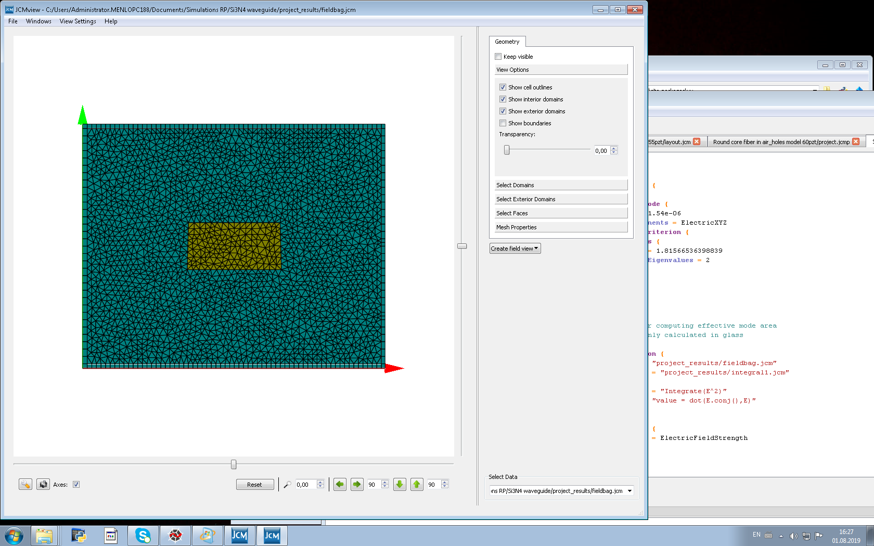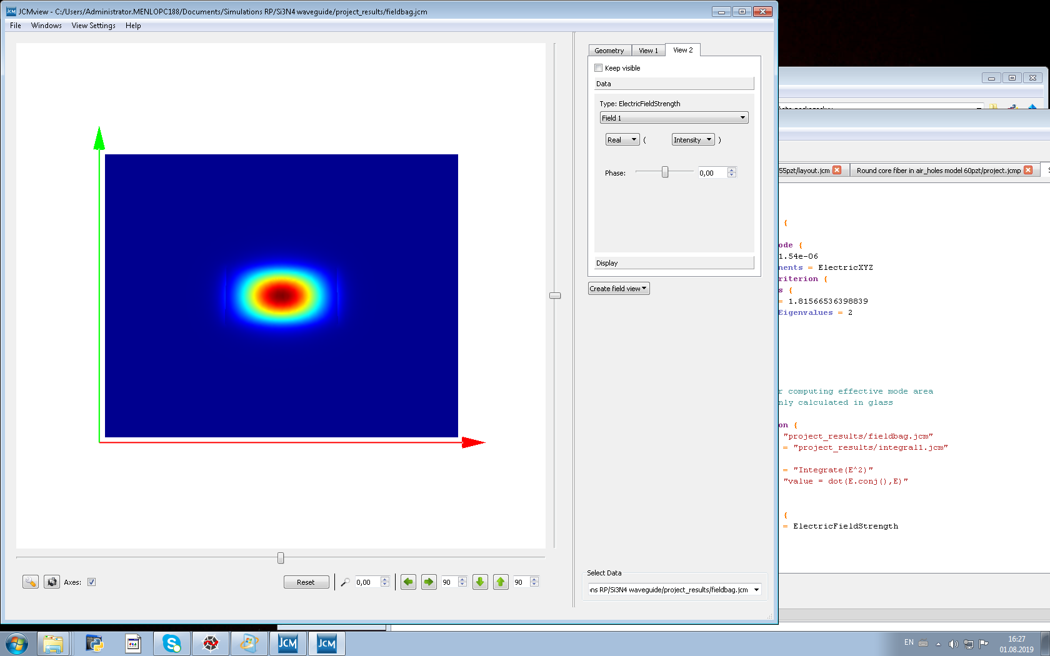

Spectral broadening simulated with PyNLO (see below). Right side: Spectrum. Left side: time-domain. Top: Light at waveguide input (gray line) and output (blue line). Bottom: Evolution along the waveguide. The white dotted lines mark the zero-dispersion points in the spectrum.

**1550 nm**

1.6 µm width, 70 mW, 130 fs, slow axis:

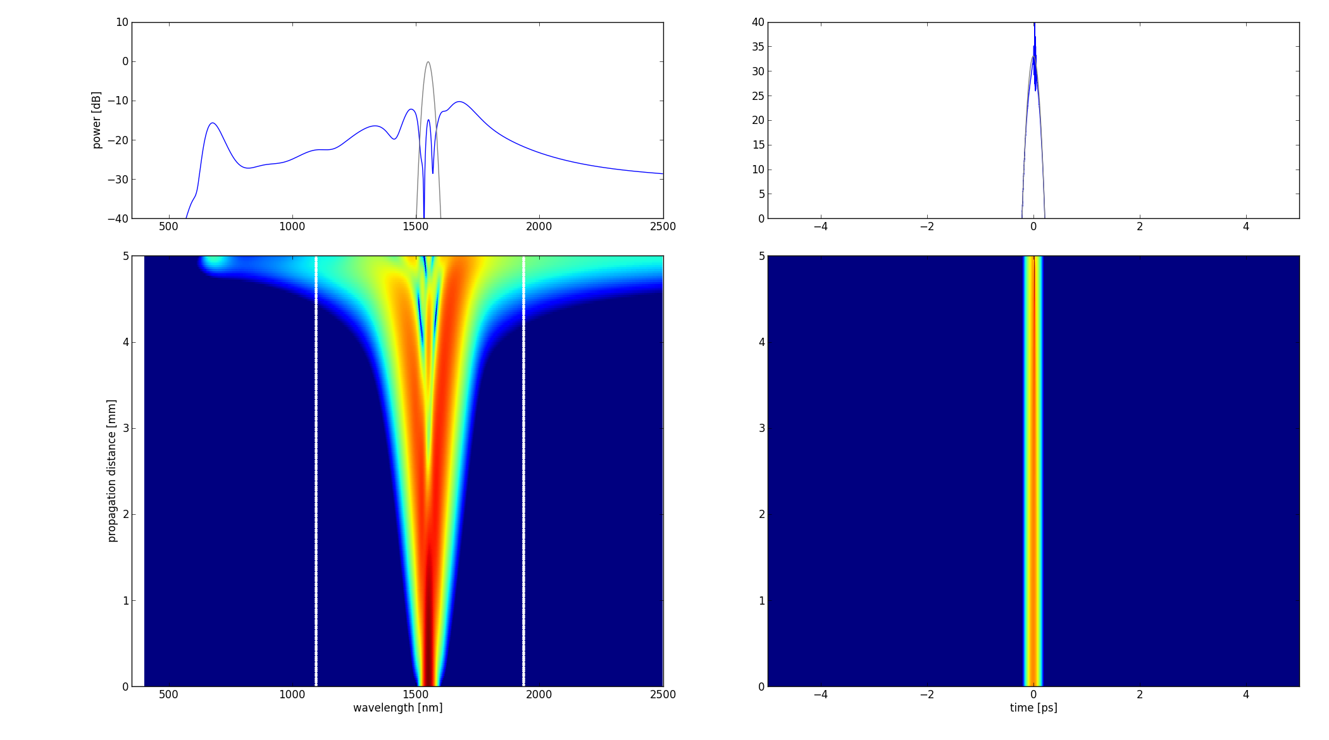

1.6 µm width, 40 mW, 100 fs, slow axis:

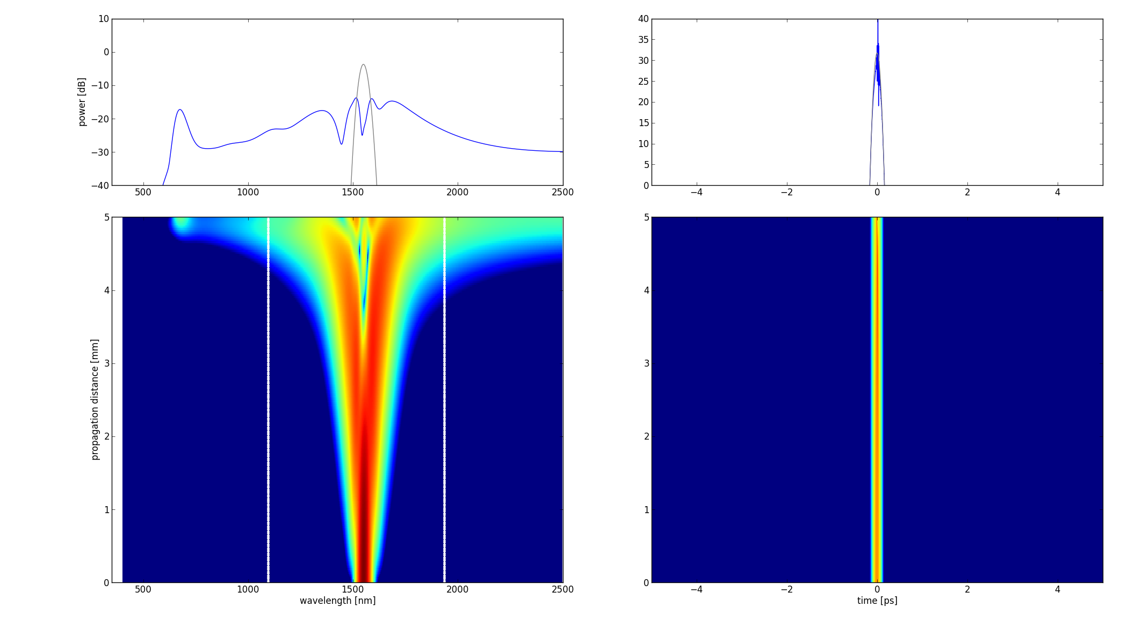

Power minimum is reached for 1.3-1.4 µm width.

The blue edge moves further to the blue as the waveguide width decreases; spike at blue edge becomes sharper.

On the fast axis, the minimum power is reached at 1.6 µm waveguide width. The blue edge is at slightly shorter wavelengths than on the slow axis. Power requirement is generally higher.

1.6 µm width, 100 mW power, 130 fs, fast axis:

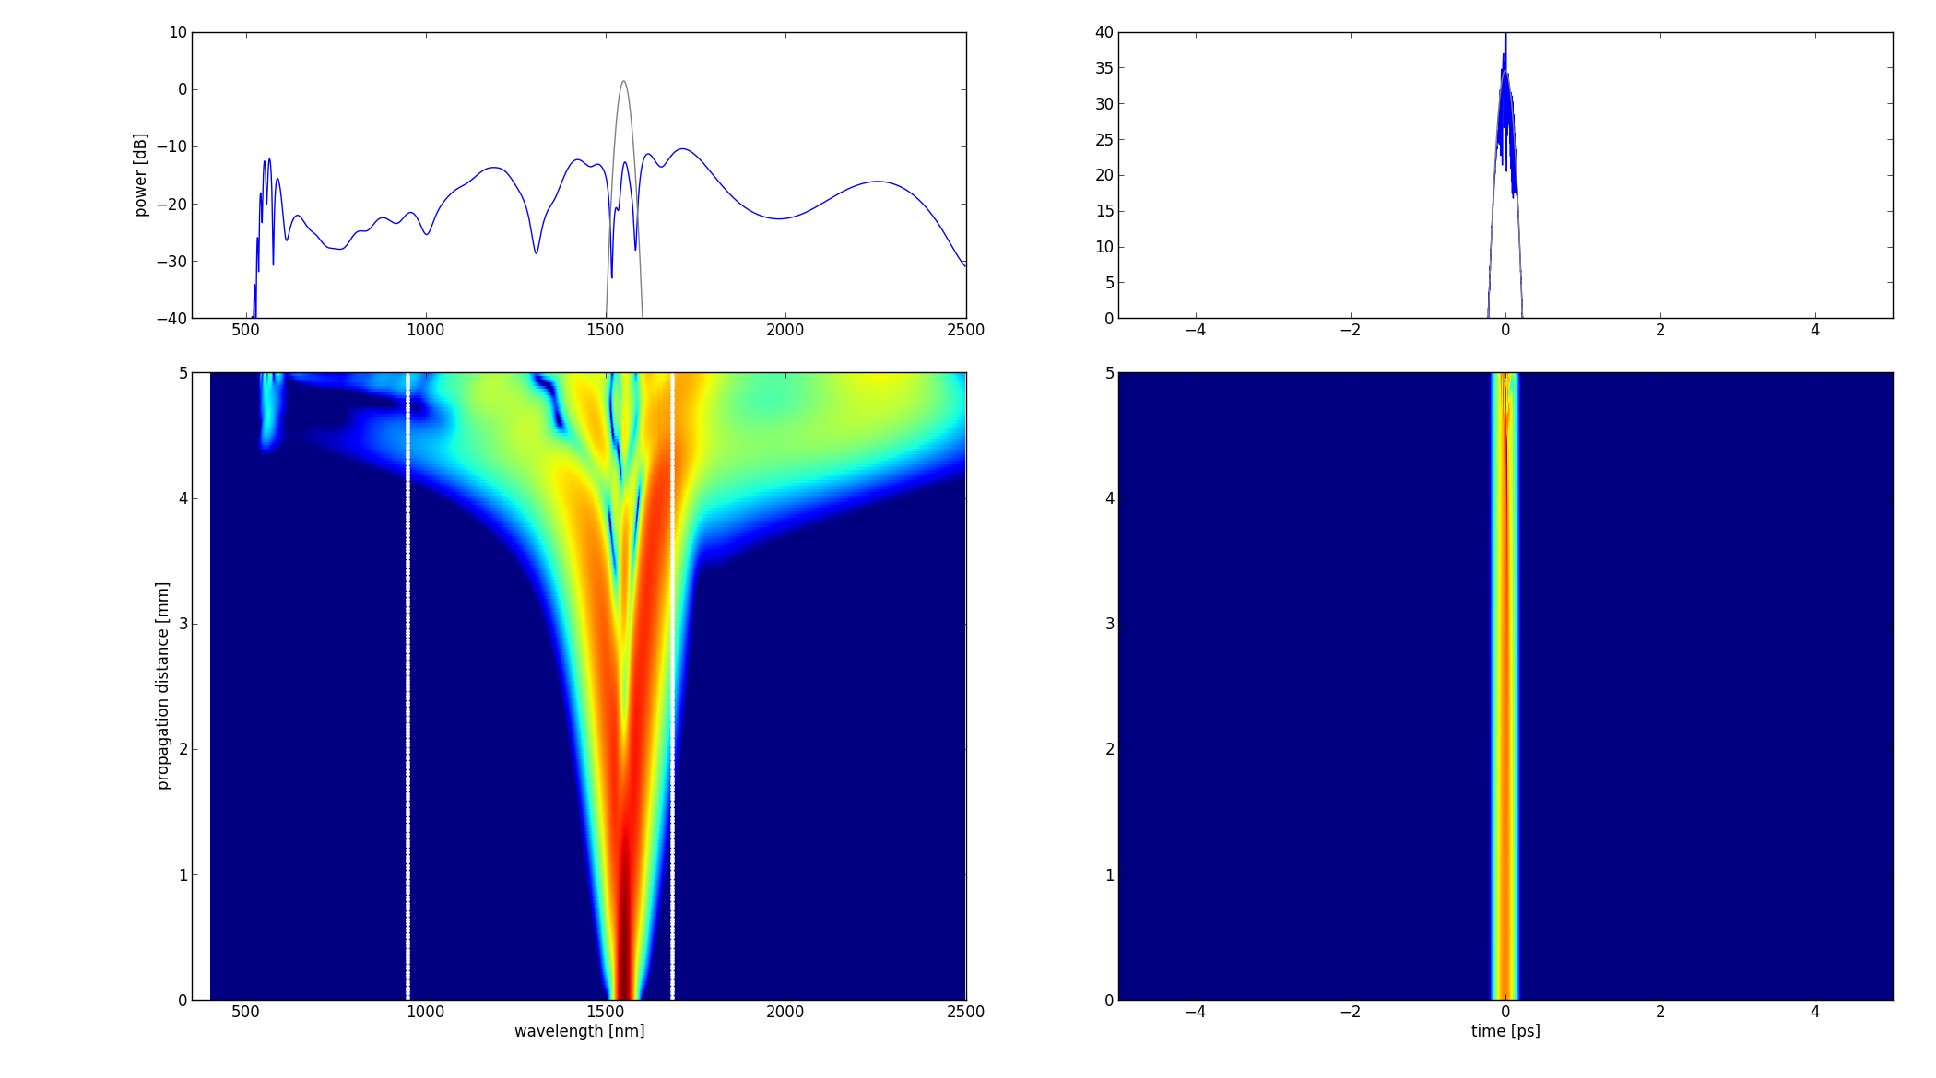

Power threshold for broadening at 1550 nm:

|  |  |  |  |  |
| --- | --- | --- | --- | --- |
| **1550 nm pump** | *Fast axis* | | *Slow axis* | |
| *Waveguide width* | *130 fs* | *100 fs* | *130 fs* | *100 fs* |
| 1.0 µm | 135 mW | 90 mW | 95 mW | 62 mW |
| 1.1 µm | 102 mW | 72 mW * | 72 mW | 45 mW |
| 1.2 µm | 98 mW | 63 mW * | 63 mW | 38 mW |
| 1.3 µm | 93 mW | 59 mW * | 60 mW | 36 mW |
| 1.4 µm | 90 mW | 57 mW * | 60 mW | 36 mW |
| 1.5 µm | 89 mW | 55 mW * | 64 mW | 38 mW |
| 1.6 µm | 87 mW | 53 mW * | 70 mW | 40 mW |
| 1.7 µm | 89 mW | 55 mW * | 78 mW | 43 mW |
| 1.8 µm | 92 mW | 57 mW * | 87 mW | 47 mW |
| 1.9 µm | 95 mW | 59 mW * | 100 mW | 54 mW |
| 2.0 µm | 98 mW | 90 mW * | 120 mW | 64 mW |

* Blue dispersive wave very weak (or not present)

The slow axis is clearly better for broadening. 35 mW at the power minimum at 100 fs works also well, spectrum even a bit less structured.

**1050 nm**

0.75 µm width, 50 mW, 130 fs, fast axis:

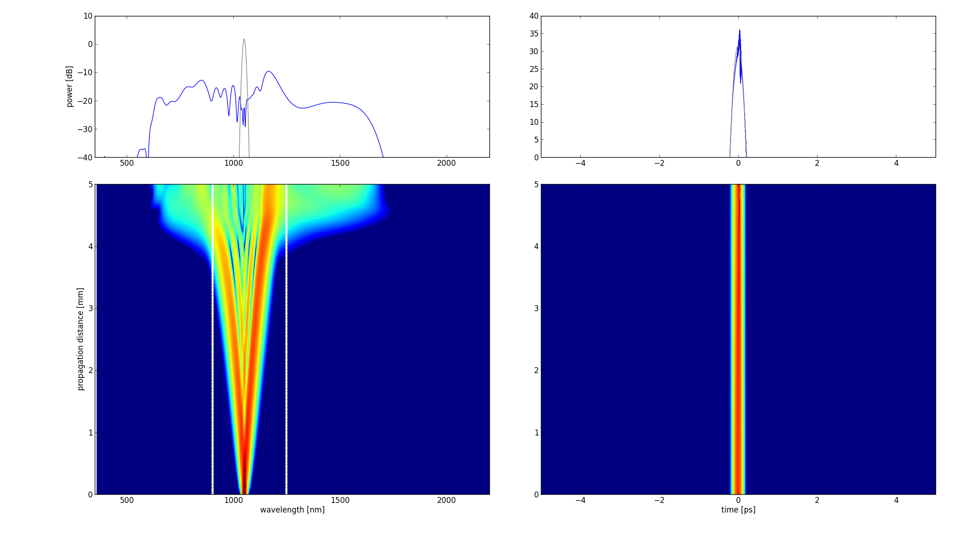

0.95 µm width, 50 mW, 130 fs, fast axis:

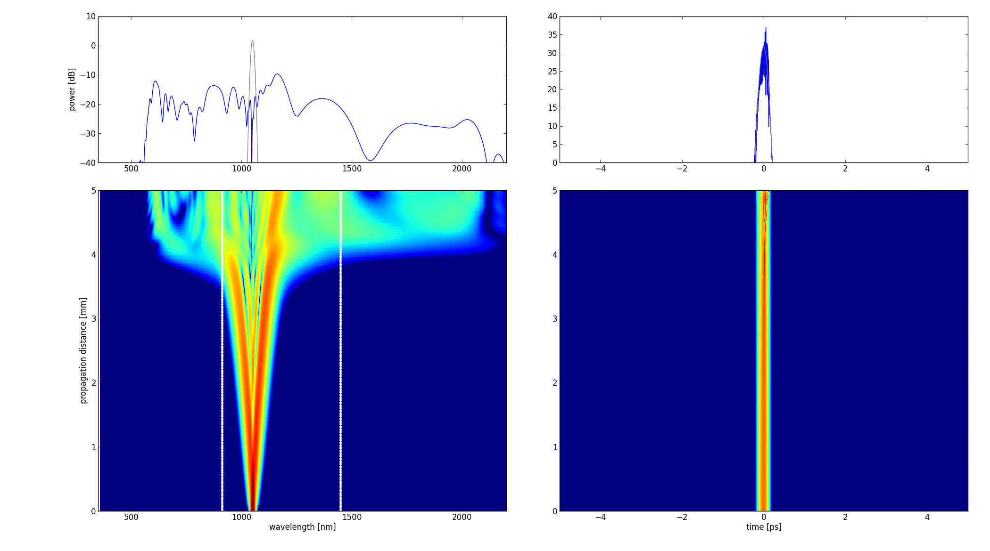

Power threshold for broadening at 1050 nm:

|  |  |  |  |  |
| --- | --- | --- | --- | --- |
| **1550 nm pump** | *Fast axis* | | *Slow axis* | |
| *Waveguide width* | *130 fs* | *100 fs* | *130 fs* | *100 fs* |
| 0.70 µm | 66 mW | 30 mW | 70 mW | 37 mW |
| 0.75 µm | 50 mW | 23 mW | 53 mW | 26 mW |
| 0.80 µm | 43 mW | 20 mW | 43 mW | 21 mW |
| 0.85 µm | 40 mW | 21 mW | 41 mW | 22 mW |
| 0.90 µm | 39 mW | 22 mW | 44 mW | 23 mW |
| 0.95 µm | 40 mW | 23 mW | 50 mW | 25 mW |
| 1.00 µm | 42 mW | 25 mW | 57 mW | 28 mW |
| 1.10 µm | 45 mW | 26 mW | 70 mW | 36 mW |
| 1.20 µm | 53 mW | 27 mW | 90 mW | 50 mW |
| 1.30 µm | 51 mW | 29 mW | 110 mW | 65 mW |
| 1.40 µm | 55 mW | 30 mW | 145 mW | 85 mW |

Fast axis: The broadest spectrum is reached at 1.0 µm width (0.95 for 100 fs). This is because the red dispersive wave moves out to longer wavelengths (while becoming weaker) with the long-wavelength ZDW. It then starts to fade away.

The slow axis is similar. No surprise, because at the optimum, the waveguide is nearly quadratic. Largest bandwidth also at ~1.0 µm. For 100 fs, long-wl. dispersive wave fades already at 0.95 µm width.